***The Gathering of God’s People***

Welcome

Candle Lighting

Gathering Song

Scripture/Gospel

Dinner Prayer

Eating along with Table Talk

Offering

Offertory

Song

Bidding Prayer

Lord’s Prayer

Blessing

Sending Song

**Table Talk:**

Start with your High of the Day and Low of the day

* What has been your favorite Olympic sport to watch?
* Do you consider yourself a risk taker?
* When reflecting on challenges in life and the experience of falling while skating, Scott Hamilton says, “It’s how you get up, because the more times you get up, the stronger you are to face the next thing, which will happen, because… that’s life.”  How is this statement true to your experience of life and faith?

***February 28, 2018***

***Self-Preservation***

A close up of a sign

Description generated with very high confidence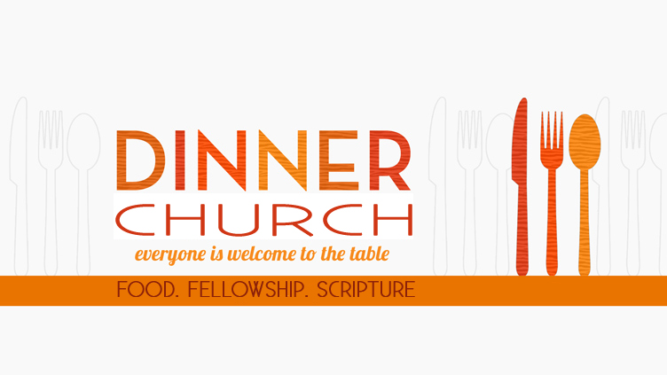

**Chorus**

**O the wonderful cross, O the wonderful cross**

**Bids me come and die**

**And find that I may truly live.**

**O the wonderful cross, O the wonderful cross;**

**All who gather here**

**By grace draw near** **and bless You name.**

**Verse 3**

**Were the whole realm of nature mine,**

**That were an off’ring far too small.**

**Love so amazing, so divine,**

**Demands my soul, my life, my all.**

**Dinner Prayer:**

**Be present at our table, Lord.**

**Be here and everywhere adored.**

**These mercies blessed and grant that we may strengthened for thy service be. Amen.**

**Verse 4**

**I fear in the dark**

**and the doubt of my journey;**

**but courage will come with the sound of your steps by my side.**

**And with all of the family**

**you saved by your love,**

**we'll sing to your dawn**

**at the end of our journey.**

**The Lord’s Prayer:**

**Our Father, who art in heaven,**

**hallowed be thy name,   
thy kingdom come, thy will be done,   
on earth as it is in heaven.   
Give us this day our daily bread;   
and forgive us our trespasses**

**as we forgive those   
who trespass against us;**

**and lead us not into temptation,   
but deliver us from evil.   
For thine is the kingdom,**

**and the power, and the glory,**

**forever and ever.**

**Amen**

**Offertory Song:**

**Verse 1**

**When I survey the wondrous cross**

**On which the Prince of Glory died,**

**My richest gain I count but loss,**

**And pour contempt on all my pride.**

**Verse 2**

**See from His head, His hands, His feet,**

**Sorrow and love flow mingled down;**

**Did e’er such love and sorrow meet,**

**Or thorns compose so rich a crown?**

**Gathering Song:**

**Verse 1**

**Lord Jesus, you shall be my song as I journey;**

**I'll tell ev'rybody about you wherever I go:**

**you alone are our life**

**and our peace and our love.**

**Lord Jesus, you shall be my song as I journey.**

**Verse 2**

**Lord Jesus, I'll praise you as long as I journey.**

**May all of my joy be a faithful reflection of you.**

**May the earth and the sea**

**and the sky join my song.**

**Lord Jesus, I'll praise you as long as I journey.**

**Verse 3**

**As long as I live, Jesus, make me your servant,**

**to carry your cross and to share all your burdens and tears.**

**For you saved me**

**by giving your body and blood.**

**As long as I live, Jesus, make me your servant.**

**Song:**

**Lord listen to Your children praying**

**Lord send Your Spirit in this place**

**Lord listen to Your children praying**

**Send us love send us pow'r send us grace**

**Sending Song:**

**Praise God, from whom all blessings flow;**

**praise God, all creatures here below;**

**praise God above, ye heav'nly host;**

**praise Father, Son, and Holy Ghost.**

A close up of text on a white background

Description generated with high confidence